Numerical Patterns

Definition
# Source: AI Source: Provided by: [Data Path: Persons Table -> ID Column: 1, Name_En Column: Motasem Essam] -> From: [ChatGPT] on [7/11/2026]
A Numerical Pattern is a sequence of numbers that follows a specific rule or relationship. Each number in the sequence is determined by applying the same rule repeatedly.
Recognizing numerical patterns helps identify missing numbers, predict future values, and understand relationships between numbers.

Characteristics
# Source: AI Source: Provided by: [Data Path: Persons Table -> ID Column: 1, Name_En Column: Motasem Essam] -> From: [ChatGPT] on [7/11/2026]
A numerical pattern:
- Consists of an ordered sequence of numbers.
- Follows a consistent rule.
- May increase, decrease, or alternate.
- Can be finite or infinite.
- May involve one or more arithmetic operations.

General Form
# Source: AI Source: Provided by: [Data Path: Persons Table -> ID Column: 1, Name_En Column: Motasem Essam] -> From: [ChatGPT] on [7/11/2026]
A numerical pattern can be written as:
$$a_{1}, a_{2}, a_{3}, …, a_{n}$$
where:
- $a_{1}$= first term
- $a_{n}$= nth term

Types of Numerical Patterns

1. Increasing Pattern
# Source: AI Source: Provided by: [Data Path: Persons Table -> ID Column: 1, Name_En Column: Motasem Essam] -> From: [ChatGPT] on [7/11/2026]
Numbers become larger according to a rule.
Example
$$2, 4, 6, 8, 10, …$$
Rule:
Add 2 each time.

2. Decreasing Pattern
# Source: AI Source: Provided by: [Data Path: Persons Table -> ID Column: 1, Name_En Column: Motasem Essam] -> From: [ChatGPT] on [7/11/2026]
Numbers become smaller according to a rule.
Example
$$20, 18, 16, 14, 12, …$$
Rule:
Subtract 2 each time.

3. Constant Difference Pattern
# Source: AI Source: Provided by: [Data Path: Persons Table -> ID Column: 1, Name_En Column: Motasem Essam] -> From: [ChatGPT] on [7/11/2026]
Each term differs from the previous term by the same amount.
Example
$$5, 10, 15, 20, 25, …$$
Rule:
Add 5.

4. Constant Ratio Pattern
# Source: AI Source: Provided by: [Data Path: Persons Table -> ID Column: 1, Name_En Column: Motasem Essam] -> From: [ChatGPT] on [7/11/2026]
Each term is multiplied by the same number.
Example
$$3, 6, 12, 24, 48, …$$
Rule:
Multiply by 2.

5. Alternating Pattern
# Source: AI Source: Provided by: [Data Path: Persons Table -> ID Column: 1, Name_En Column: Motasem Essam] -> From: [ChatGPT] on [7/11/2026]
The rule changes in a repeating cycle.
Example
$$2, 5, 4, 7, 6, 9, …$$
Rules:
- Add 3
- Subtract 1
- Repeat

6. Square Number Pattern
# Source: AI Source: Provided by: [Data Path: Persons Table -> ID Column: 1, Name_En Column: Motasem Essam] -> From: [ChatGPT] on [7/11/2026]
Numbers are perfect squares.
Example
$$1, 4, 9, 16, 25, …$$
Rule:
$$n^{2}$$

7. Cube Number Pattern
# Source: AI Source: Provided by: [Data Path: Persons Table -> ID Column: 1, Name_En Column: Motasem Essam] -> From: [ChatGPT] on [7/11/2026]
Numbers are perfect cubes.
Example
$$1, 8, 27, 64, 125, …$$
Rule:
$$n^{3}$$

8. Triangular Number Pattern
# Source: AI Source: Provided by: [Data Path: Persons Table -> ID Column: 1, Name_En Column: Motasem Essam] -> From: [ChatGPT] on [7/11/2026]
Example
$$1, 3, 6, 10, 15, 21, …$$
Rule:
Add consecutive integers.

9. Fibonacci Pattern
# Source: AI Source: Provided by: [Data Path: Persons Table -> ID Column: 1, Name_En Column: Motasem Essam] -> From: [ChatGPT] on [7/11/2026]
Each term equals the sum of the previous two terms.
Example
$$1, 1, 2, 3, 5, 8, 13, …$$

Finding the Next Number
# Source: AI Source: Provided by: [Data Path: Persons Table -> ID Column: 1, Name_En Column: Motasem Essam] -> From: [ChatGPT] on [7/11/2026]
Example 1
$$7, 10, 13, 16, 19, ?$$
Difference:
$$+3$$
Next number:
$$\boxed{22}$$

Example 2
$$5, 10, 20, 40, ?$$
Rule:
Multiply by 2
Next number:
$$\boxed{80}$$

Example 3
$$2, 4, 8, 16, ?$$
Rule:
Multiply by 2
Next number:
$$\boxed{32}$$

Finding the Missing Number
# Source: AI Source: Provided by: [Data Path: Persons Table -> ID Column: 1, Name_En Column: Motasem Essam] -> From: [ChatGPT] on [7/11/2026]
Example
$$6, 9, 12, ?, 18$$
Rule:
Add 3
Missing number:
$$\boxed{15}$$

Number Pattern Illustration
# Source: AI Source: Provided by: [Data Path: Persons Table -> ID Column: 1, Name_En Column: Motasem Essam] -> From: [ChatGPT] on [7/11/2026]
2 → 4 → 6 → 8 → 10
+2 +2 +2 +2

Applications
# Source: AI Source: Provided by: [Data Path: Persons Table -> ID Column: 1, Name_En Column: Motasem Essam] -> From: [ChatGPT] on [7/11/2026]
Numerical patterns are used in:
- Arithmetic
- Algebra
- Number Theory
- Computer Programming
- Data Analysis
- Cryptography
- Engineering
- Scientific Modeling
- Financial Forecasting

Key Points
# Source: AI Source: Provided by: [Data Path: Persons Table -> ID Column: 1, Name_En Column: Motasem Essam] -> From: [ChatGPT] on [7/11/2026]
- A numerical pattern follows a specific rule.
- Rules may involve:
  - Addition
  - Subtraction
  - Multiplication
  - Division
  - Exponents
  - Alternating operations
- Patterns may be increasing, decreasing, alternating, arithmetic, geometric, or recursive.
- Recognizing patterns helps predict future values and solve mathematical problems.

Conclusion
# Source: AI Source: Provided by: [Data Path: Persons Table -> ID Column: 1, Name_En Column: Motasem Essam] -> From: [ChatGPT] on [7/11/2026]
A Numerical Pattern is an ordered sequence of numbers generated according to a consistent mathematical rule. These patterns may involve repeated addition, subtraction, multiplication, division, exponentiation, or recursive relationships such as the Fibonacci sequence. Numerical patterns are fundamental in arithmetic, algebra, number theory, computer programming, engineering, financial analysis, scientific modeling, and mathematical reasoning, where they are used to identify relationships, predict future values, and solve problems efficiently.

Pascal's Triangle

Definition
# Source: AI Source: Provided by: [Data Path: Persons Table -> ID Column: 1, Name_En Column: Motasem Essam] -> From: [ChatGPT] on [7/11/2026]
Pascal's Triangle is a triangular arrangement of numbers in which each number is the sum of the two numbers directly above it. The numbers along the edges are always 1.
It is named after the French mathematician Blaise Pascal, although the triangle was known centuries earlier in China, India, Persia, and the Islamic world.

Construction Rule
# Source: AI Source: Provided by: [Data Path: Persons Table -> ID Column: 1, Name_En Column: Motasem Essam] -> From: [ChatGPT] on [7/11/2026]
Pascal's Triangle is built using the following rules:
- The top row contains a single 1.
- Every row begins and ends with 1.
- Every interior number equals the sum of the two numbers directly above it.
Mathematically:
$$T\left(n , k\right)=T\left(n-1 , k-1\right)+T\left(n-1 , k\right)$$
where:
- $T\left(n , k\right)$= value at row $n$, position $k$.

Pascal's Triangle
# Source: AI Source: Provided by: [Data Path: Persons Table -> ID Column: 1, Name_En Column: Motasem Essam] -> From: [ChatGPT] on [7/11/2026]
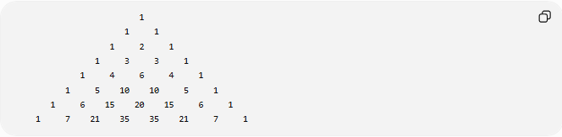
1
1 1
1 2 1
1 3 3 1
1 4 6 4 1
1 5 10 10 5 1
1 6 15 20 15 6 1
1 7 21 35 35 21 7 1

First Rows
# Source: AI Source: Provided by: [Data Path: Persons Table -> ID Column: 1, Name_En Column: Motasem Essam] -> From: [ChatGPT] on [7/11/2026]
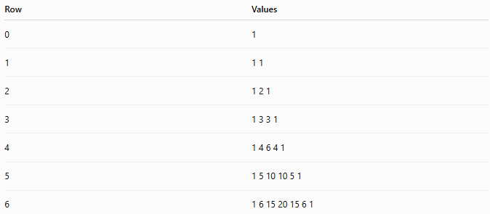
Row | Values
0 | 1
1 | 1 1
2 | 1 2 1
3 | 1 3 3 1
4 | 1 4 6 4 1
5 | 1 5 10 10 5 1
6 | 1 6 15 20 15 6 1

Properties
# Source: AI Source: Provided by: [Data Path: Persons Table -> ID Column: 1, Name_En Column: Motasem Essam] -> From: [ChatGPT] on [7/11/2026]
1. Edge Property
The first and last numbers of every row are:
$$1$$

2. Addition Property
Each interior value equals:
$$\text{Left Above}+\text{Right Above}$$
Example:
$$10=4+6$$

3. Symmetry Property
Each row is symmetric.
Example:
$$1, 5, 10, 10, 5, 1$$
reads the same from both directions.

4. Row Sum Property
The sum of the numbers in row $n$is:
$$2^{n}$$
Examples:
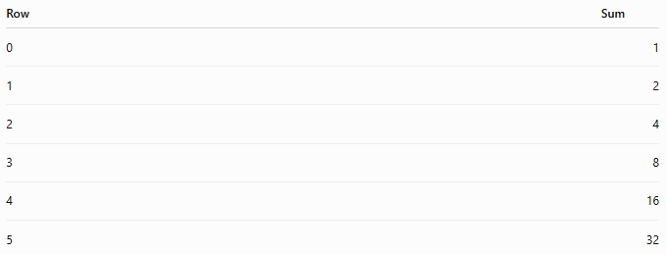
Row | Sum
0 | 1
1 | 2
2 | 4
3 | 8
4 | 16
5 | 32

5. Diagonal Patterns
Different diagonals generate famous number sequences.
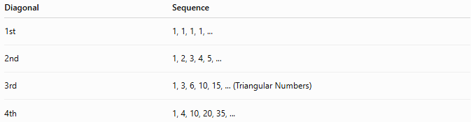
Diagonal | Sequence
1st | 1, 1, 1, 1, ...
2nd | 1, 2, 3, 4, 5, ...
3rd | 1, 3, 6, 10, 15, ... (Triangular Numbers)
4th | 1, 4, 10, 20, 35, ...

Relationship to Binomial Coefficients
# Source: AI Source: Provided by: [Data Path: Persons Table -> ID Column: 1, Name_En Column: Motasem Essam] -> From: [ChatGPT] on [7/11/2026]
Each entry equals a binomial coefficient:
$$\left({n \atop k}\right)$$
Thus, row $n$contains:
$$\left({n \atop 0}\right),\left({n \atop 1}\right),\left({n \atop 2}\right),…,\left({n \atop n}\right)$$

Examples
# Source: AI Source: Provided by: [Data Path: Persons Table -> ID Column: 1, Name_En Column: Motasem Essam] -> From: [ChatGPT] on [7/11/2026]
Example 1
Find the next row after:
$$1, 4, 6, 4, 1$$
Next row:
$$1, 5, 10, 10, 5, 1$$

Example 2
Complete the row:
$$1, 6, ?, 20, 15, 6, 1$$
Missing value:
$$15$$
Completed row:
$$1, 6, 15, 20, 15, 6, 1$$

Applications
# Source: AI Source: Provided by: [Data Path: Persons Table -> ID Column: 1, Name_En Column: Motasem Essam] -> From: [ChatGPT] on [7/11/2026]
Pascal's Triangle is used in:
- Arithmetic
- Algebra
- Binomial Expansion
- Combinatorics
- Probability
- Number Theory
- Computer Science
- Statistics
- Discrete Mathematics

Key Points
# Source: AI Source: Provided by: [Data Path: Persons Table -> ID Column: 1, Name_En Column: Motasem Essam] -> From: [ChatGPT] on [7/11/2026]
- Begins with a single 1.
- Every row starts and ends with 1.
- Every interior value equals the sum of the two numbers above it.
- Row $n$sums to:
$$2^{n}$$
- Each value is a binomial coefficient:
$$\left({n \atop k}\right)$$
- The triangle contains many important number patterns and mathematical relationships.

Conclusion
# Source: AI Source: Provided by: [Data Path: Persons Table -> ID Column: 1, Name_En Column: Motasem Essam] -> From: [ChatGPT] on [7/11/2026]
Pascal's Triangle is one of the most important numerical patterns in mathematics. Constructed by repeatedly adding adjacent numbers from the previous row, it reveals deep relationships between arithmetic, combinatorics, probability, and algebra. Each row corresponds to the binomial coefficients used in the Binomial Theorem, while its diagonals generate well-known number sequences such as the triangular numbers. Pascal's Triangle is widely used in arithmetic, algebra, combinatorics, probability, statistics, computer science, and number theory.

